Sprint - 2

|  |  |
| --- | --- |
| Date | 17 November 2022 |
| Team ID | PNT2022TMID14015 |
| Project Name | Smart Fashion Recommender Application |

Creating UI for Admin Panel

Admin Login

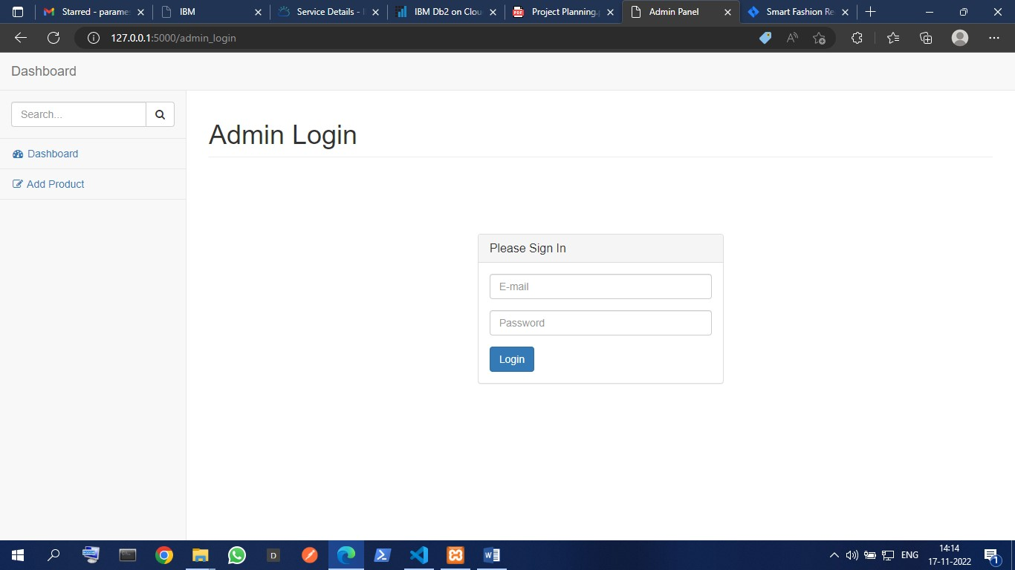

Admin Panel

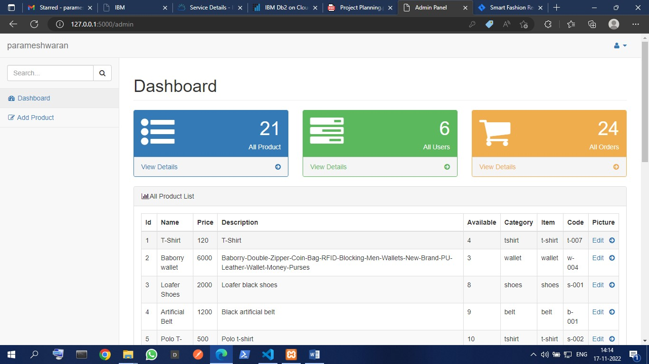

Creating database connection for admin panel

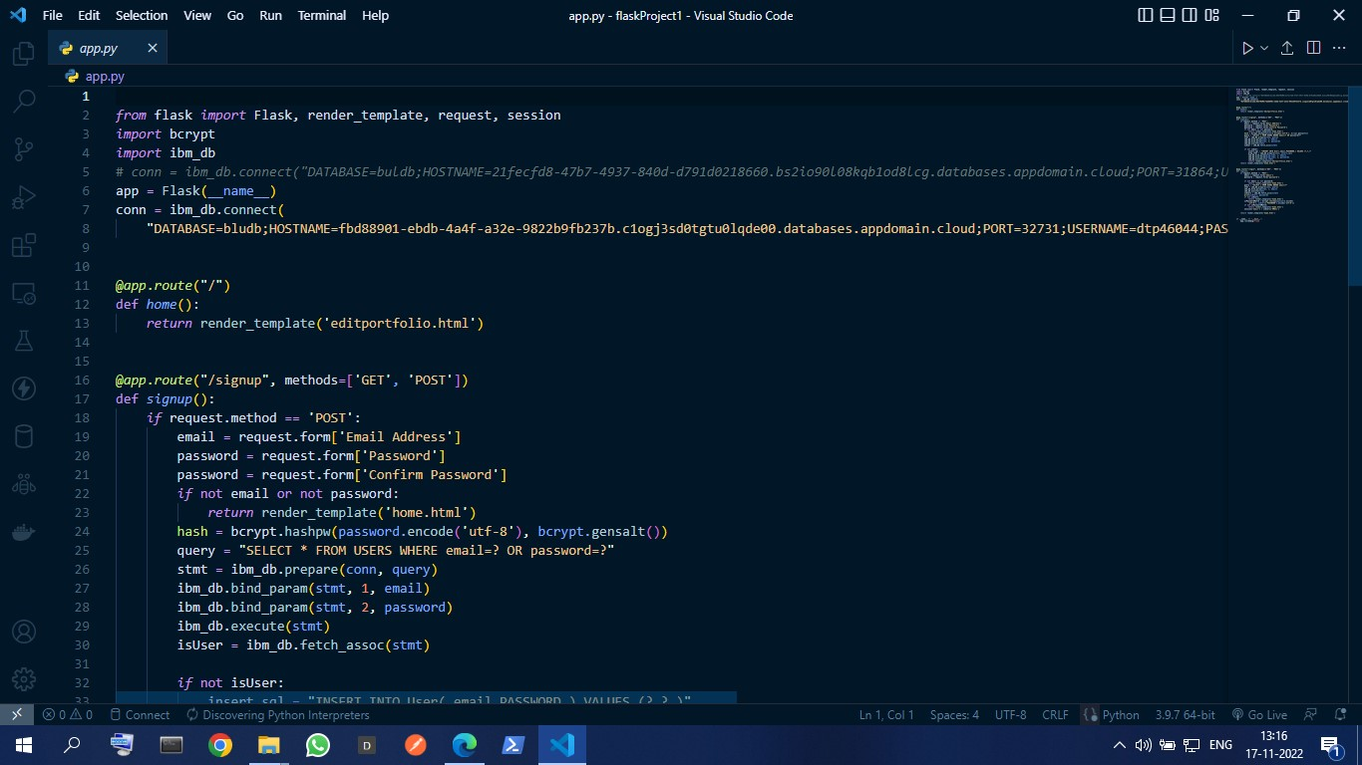

Completing the Admin panel

Add Product

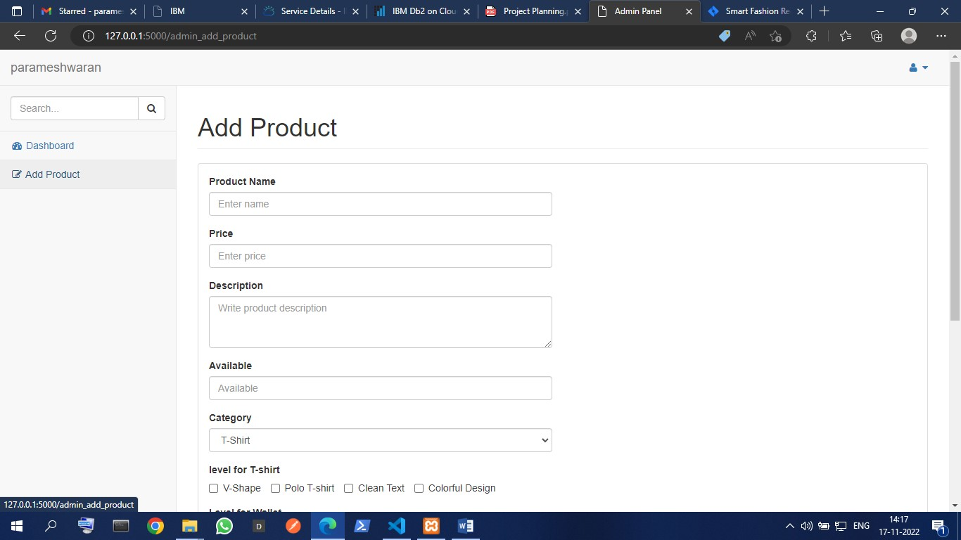

Dashboard

